

American International University-Bangladesh (AIUB)
Department of Computer Science
Faculty of Science & Technology (FST)

Online Quiz Management System
Semester: Spring 25-26

Group:03 |  | Section: C
SL | Student Name | Student ID
1 | Sheikh Mahfuzur Rahman | 24-55917-1
2 | Mohammed Ali Khorasani | 24-55920-1
3 | Ashiful Islam Nabil | 24-55928-1
4 | Jakaria Islam Raad | 24-55949-1
5 | Fahmida Faiza | 24-56431-1

Table of Contents

1. Project Proposal xx
1.1 Background to the Problem xx
1.2 Selection of Process Model xx
2. Timeline Chart / Gantt Chart ………………………….………………………………………………………………...xx
3. Software Requirements Specification (SRS) / PRD xx
3.1 Scopes and Features xx
3.2 User Story Table xx
3.3 Requirements Traceability Matrix xx
3.3.1 Functional Requirements xx
3.3.2 Non-Functional Requirements xx
4. Software Design xx
4.1 System Deisgn xx
4.2 UI Deisgn using Figma xx
5. Git Workflow xx
6. Software Testing xx
7. Conclusion xx

1. PROJECT PROPOSAL

  - Background to the Problem

The rapid growth of online education and digital learning platforms has increased the demand for efficient and reliable online assessment systems. Traditional quiz and examination methods, such as paper-based tests or manual evaluations, are time-consuming, error-prone, and difficult to manage for large numbers of participants. These limitations often lead to delayed results, lack of transparency, and increased administrative workload.Existing online quiz systems provide basic functionalities such as quiz creation and participation, but many lack advanced features like real-time result processing, secure authentication, anti-cheating mechanisms, and user role management. Issues such as tab switching, impersonation, and unfair practices reduce the credibility of online assessments.To address these challenges, the proposed Online Quiz Competition System aims to develop a secure, automated, and user-friendly platform that supports multiple users simultaneously. The system introduces features such as role-based access control (Admin, Examiner, Participant), instant result generation, leaderboard ranking, facecam verification, and tab-switch prevention.This project improves upon existing systems by enhancing security, automation, and user experience, ensuring fair evaluation and efficient quiz management in educational institutions and organizations.

  - Selection of Process Model
- For the development of the Online Quiz Competition System, the Agile Software Development Model using the Scrum framework has been selected as the most suitable approach.
- Agile is an iterative and incremental process model where the system is developed in small cycles called sprints. Each sprint delivers a working portion of the system, allowing continuous testing, evaluation, and improvement. This ensures that the final product is reliable, flexible, and aligned with user requirements.
- The Scrum-based Agile model is particularly appropriate for this project because the system consists of several independent yet interconnected modules, such as user management, quiz management, participation, result processing, and advanced security features like facecam verification and anti-cheating mechanisms. These modules can be efficiently developed and refined across multiple sprints.
- A major advantage of Agile is its flexibility in handling changing requirements. As the project progresses, feedback from testing or users can be incorporated without disrupting the overall system. This is highly beneficial for this project, where usability, performance, and security may require continuous enhancement.
- Scrum also defines clear roles to improve team coordination and productivity:
- Product Owner: Defines system requirements and prioritizes features
- Scrum Master: Ensures the Agile process is followed and removes obstacles
- Development Team: Designs, develops, and tests the system
Regular meetings such as sprint planning, daily stand-ups, sprint reviews, and retrospectives help maintain effective communication and continuous improvement.
Agile Scrum Implementation (Sprint Plan):
- Sprint 1: User Registration, Login & Authentication
- Sprint 2: Quiz Creation & Management
- Sprint 3: Quiz Participation & Timer System
- Sprint 4: Result Generation & Leaderboard
- Sprint 5: Security Features (Facecam Verification & Anti-cheating)
Each sprint includes requirement analysis, system design, implementation, testing, and feedback, ensuring the delivery of a high-quality and user-friendly system.

2. Timeline Chart / Gantt Chart

Task / Module | Week 1 | Week 2 | Week 3 | Week 4 | Week 5
Requirement Analysis & Planning | ████
UI Design (Figma) | ████ | ███
User Registration & Login | ████ | ███
Quiz Creation & Management |  | ████ | ███
Quiz Attempt & Timer |  |  | ████ | ███
Result & Leaderboard |  |  |  | ████ | ███
Security Features |  |  |  |  | ████
Testing & Debugging |  |  |  | ███ | ████
Final Review & Documentation |  |  |  |  | ████

3. SOFTWARE REQUIREMENTS SPECIFICATIONS (SRS) / PRODUCT REQUIREMENTS DOCUMENT (PRD)

3.1 Scopes and Features
Scope 1: User Management
- User registration and login system
- Secure authentication (email & password)
- Profile management (update name, password, etc.)
- Role-based access control (Admin, Examiner & Participant)
- Logout functionality
- Password validation and basic security features

Scope 2: Quiz Management
- Admin can create, update, and delete quizzes
- Add, edit, and remove multiple-choice questions (MCQ)
- Set quiz duration and total marks
- Define correct answers for automatic evaluation
- Organize quizzes by category or topic
- Control quiz availability (start/end time)
· Examiner can create questions and evaluate results

Scope 3: Participation & Result
- Users can view available quizzes
- Users can join and attempt quizzes
- Timer-based quiz execution
- Auto submission when time ends
- Instant result generation after submission
- Display score and correct answers
- Leaderboard/ranking system based on performance
· Facecam verification required before quiz
· User cannot switch tab during quiz

Scope 4: System & Performance
- System supports multiple users at the same time
- Fast response and smooth performance
- Data security and user authentication
- Simple and user-friendly interface
- Accessible from web browsers (PC/mobile)

3.2 User Story Table

ID | User Story
US1 | As a user, I want to register so that I can participate in quizzes
US2 | As a user, I want to log in to access quizzes
US3 | As a user, I want to attempt quizzes
US4 | As a user, I want to see my results
US4 | As an admin, I want to create quizzes
US5 | As an admin, I want to add questions
US6 | As an admin, I want to manage users
US7 | As an admin, I want to view results
US8 | As an examiner, I want to create questions
US9 | As an examiner, I want to evaluate results
US10 | System verifies facecam
US11 | System prevents tab switching

3.3 Requirements Traceability Matrix

3.3.1 Functional Requirements
Sl No | Module | Screen Definition | User Story | Acceptance Criteria
1 | SIGNUP | Name, Email, Password | User registers | Email must be unique and in valid format; Password must be at least 6 characters; All fields are required; Error message shown for invalid input; Successful registration redirects to login page
2 | LOGIN | Email, Password | User logs in | Only registered users can log in; Correct email and password required; Error message for invalid credentials; Session created after login; Redirect to dashboard after success
3 | ADMIN | Quiz fields | Admin manages quiz | Admin can create, update, and delete quizzes; Quiz must include title, duration, and marks; Changes are saved in database; Only admin has access; Confirmation message shown after actions
4 | QUESTION | MCQ fields | Add questions | Each question must have 4 options; One correct answer must be selected; Cannot submit empty question; Questions must be linked to a quiz; Questions can be edited and deleted
5 | QUIZ | Quiz list | Attempt quiz | User can access only available quizzes; Timer starts when quiz begins; Auto-submit when time ends; User cannot attempt same quiz multiple times (if restricted); Answers are saved properly
6 | RESULT | Score | View result | Result generated instantly after submission; Score calculated correctly; Correct and incorrect answers displayed; Result stored in system; User can view previous results

3.3.2 Non-Functional Requirements
Sl No | Specification | User Story | Acceptance Criteria
1 | Performance | Fast system | System response time ≤ 2–3 seconds; Supports multiple users simultaneously; No lag during quiz attempt; Fast page loading
2 | Security | Secure system | Password must be encrypted; Secure login authentication; Prevent unauthorized access; Session timeout after inactivity; Protection against basic attacks (e.g., SQL injection)
3 | Usability | Easy UI | Simple and user-friendly interface; Easy navigation; Responsive design (mobile & PC); Clear instructions; Minimal user errors

4. SOFTWARE DESIGN
4.1. Use Case Diagram:
- Actors:
- Admin
- · Admin
· Examiner
· Participant
- Description:
The admin controls the system by managing quizzes and users. Participants register, log in, take quizzes, and view results.
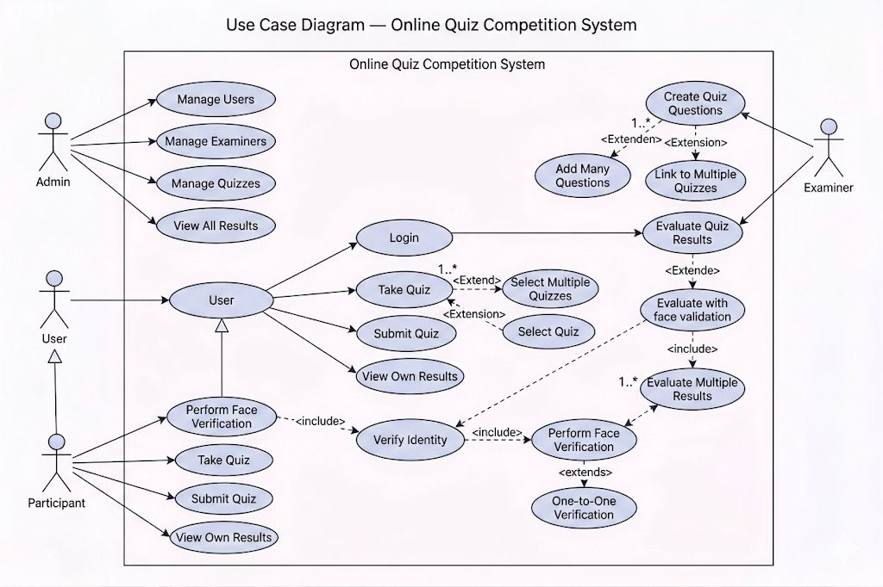
Class Diagram:
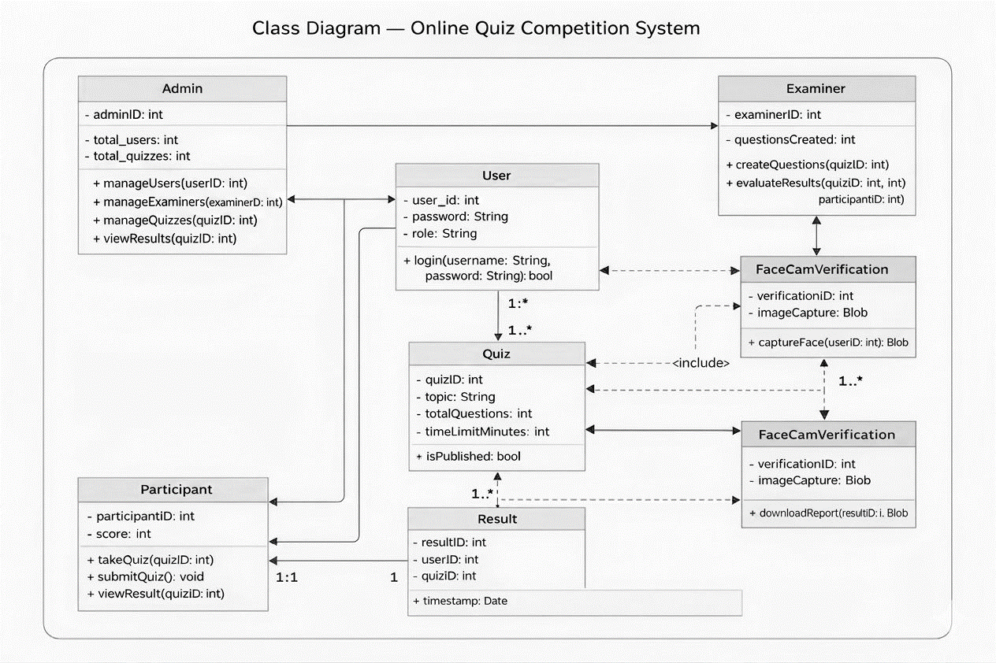

UI / Wireframe Design using Figma

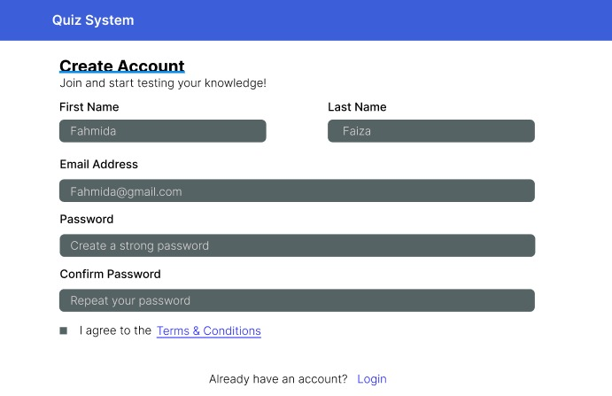
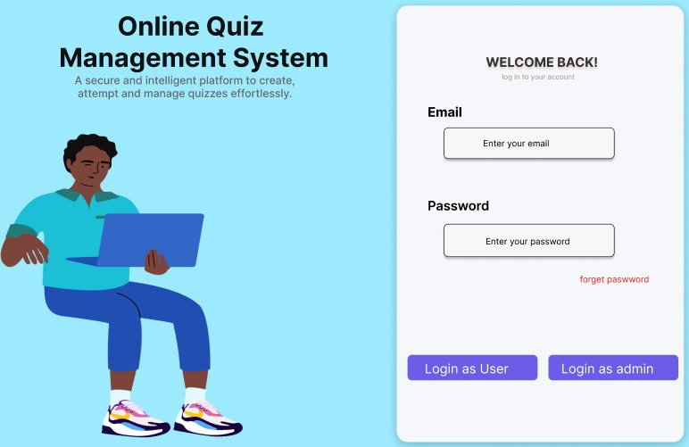

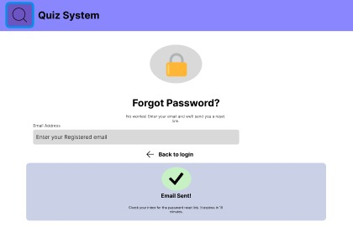

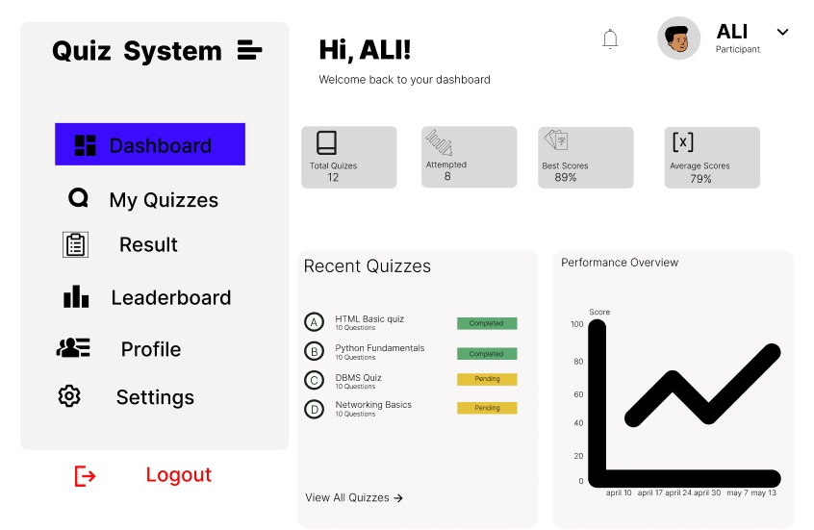

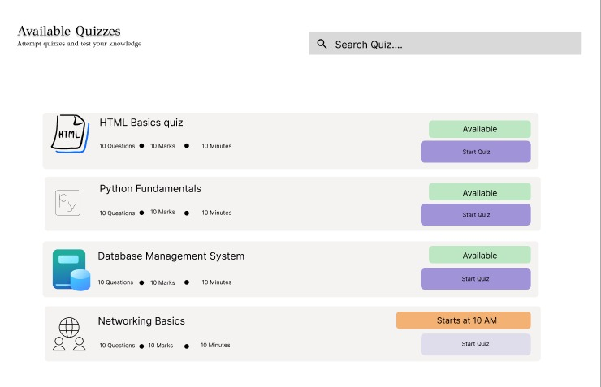

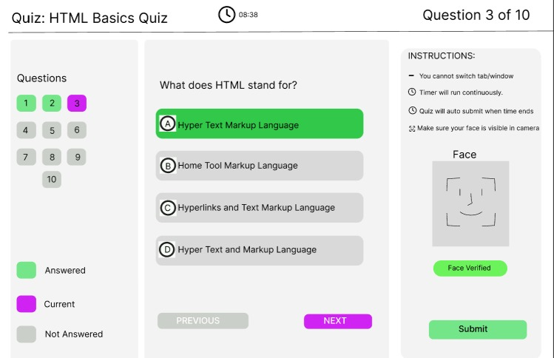
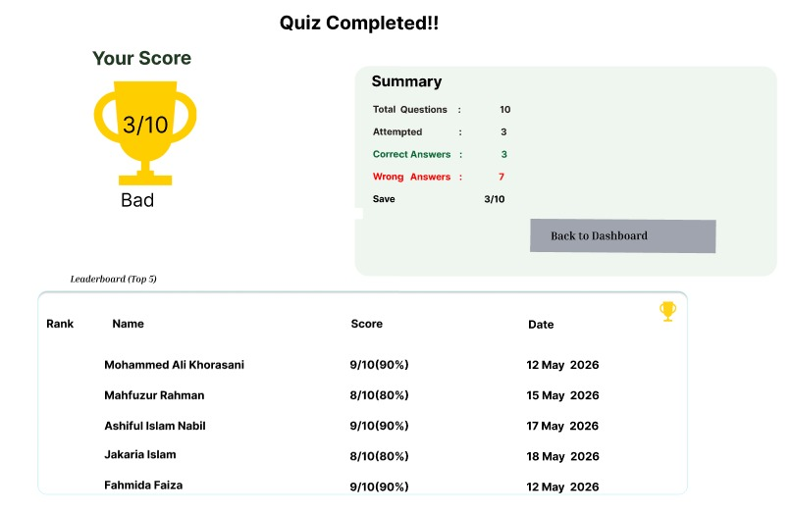
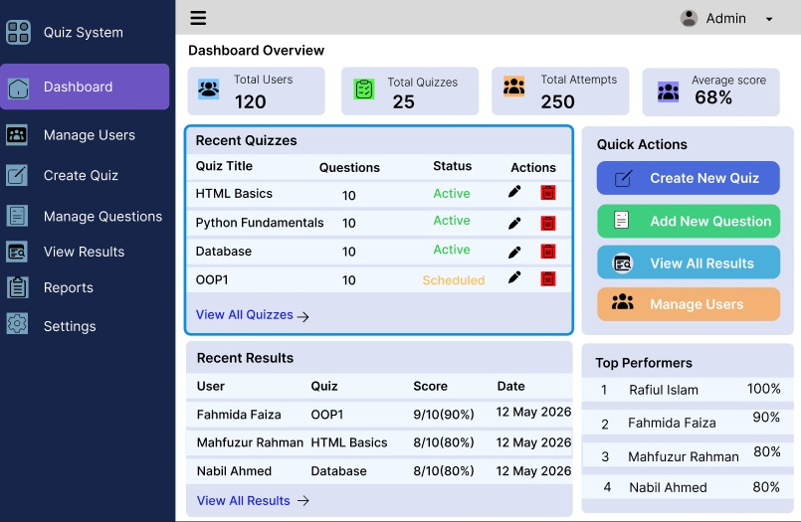

5. GIT WORKFLOW
- Create a central repository for the project on GitHub and set the master (or main) branch as the primary branch for integration.
- Each member should clone the repository and create their own feature branches for assigned tasks. Work on new features or fixes within these branches.
- Add files based on Trello cards, stage them and commit changes with clear messages that describe the purpose of each update. The text files (where the card serial, description are available based on Trello board) should be uploaded in the Git repository.
- Push commits from the feature branches to the remote repository so other members can see progress.
- Use pull to fetch and integrate changes from the remote repository into local copies, ensuring everyone stays updated.
- Merge feature branches into the master/main branch only after the work is tested and reviewed, resolving any conflicts that occur.
- Show evidence of collaboration by maintaining a clear commit history (using logs) with multiple commits, merges and contributions from all group members.
- Keep the repository organized with a clean history that tracks the project workflow from initialization to completion.
- Lastly, add the “Final Trello Board” screenshot in this section.

6. SOFTWARE TESTING

Project Name: Online Quiz System | Test Designed by: Ashiful Islam Nabil
Test Case ID: TC_1 | Test Designed date: 02/07/2025
Test Priority: Medium | Test Executed by: Ashiful Islam Nabil
Module Name: Login Session | Test Execution date: 22/08/2025
Test Title: Verify login
Description: Testing system

Precondition: User ready
Dependencies: if any
Test Steps | Test Data | Expected Results | Actual Results | Status
1. Go to login  2. Enter email  3. Enter password  4. Click login | Email: nabil@gmail.com  Pass: 123456 | User logs in | As expected | Pass

Project Name: Online Quiz System | Test Designed by: Ashiful Islam Nabil
Test Case ID: TC_2 | Test Designed date: 02/07/2025
Test Priority: Medium | Test Executed by: Ashiful Islam Nabil
Module Name: Login Session | Test Execution date: 22/08/2025
Test Title: Invalid login
Description: Testing system
Precondition: User ready
Dependencies: if any
Test Steps | Test Data | Expected Results | Actual Results | Status
Enter wrong password | Email: nabil@gmail.com  Pass: wrong | Error shows | As expected | Pass

Project Name: Online Quiz System | Test Designed by: Jakariya Islam Raad
Test Case ID: TC_3 | Test Designed date: 02/07/2025
Test Priority: Medium | Test Executed by: Jakariya Islam Raad
Module Name: Signup | Test Execution date: 22/08/2025
Test Title: Verify signup
Description: Testing system

Precondition: User ready
Dependencies: if any
Test Steps | Test Data | Expected Results | Actual Results | Status
Fill form & submit | Name: Raad  Email: raad@gmail.com  Pass: 123456 | Account created | As expected | Pass

Project Name: Online Quiz System | Test Designed by: Jakariya Islam Raad
Test Case ID: TC_4 | Test Designed date: 02/07/2025
Test Priority: Medium | Test Executed by: Jakariya Islam Raad
Module Name: Signup | Test Execution date: 22/08/2025
Test Title: Empty signup
Description: Testing system

Precondition: User ready
Dependencies: if any
Test Steps | Test Data | Expected Results | Actual Results | Status
Submit empty form | — | Validation error | As expected | Pass

Project Name: Online Quiz System | Test Designed by: Mohammed Ali Khorasani
Test Case ID: TC_5 | Test Designed date: 02/07/2025
Test Priority: Medium | Test Executed by: Mohammed Ali Khorasani
Module Name: Quiz | Test Execution date: 22/08/2025
Test Title: Start quiz
Description: Testing system

Precondition: User ready
Dependencies: if any
Test Steps | Test Data | Expected Results | Actual Results | Status
Click start quiz | HTML Quiz | Quiz opens | As expected | Pass

Project Name: Online Quiz System | Test Designed by: Mohammed Ali Khorasani
Test Case ID: TC_6 | Test Designed date: 02/07/2025
Test Priority: Medium | Test Executed by: Mohammed Ali Khorasani
Module Name: Quiz | Test Execution date: 22/08/2025
Test Title: Answer select
Description: Testing system

Precondition: User ready
Dependencies: if any
Test Steps | Test Data | Expected Results | Actual Results | Status
Select option | Option A | Answer saved | As expected | Pass

Project Name: Online Quiz System | Test Designed by: Sheikh Mahfuzur Rahman
Test Case ID: TC_7 | Test Designed date: 02/07/2025
Test Priority: Medium | Test Executed by: Sheikh Mahfuzur Rahman
Module Name: Result | Test Execution date: 22/08/2025
Test Title: View result
Description: Testing system

Precondition: User ready
Dependencies: if any
Test Steps | Test Data | Expected Results | Actual Results | Status
Submit quiz | — | Result shown | As expected | Pass

Project Name: Online Quiz System | Test Designed by: Sheikh Mahfuzur Rahman
Test Case ID: TC_8 | Test Designed date: 02/07/2025
Test Priority: Medium | Test Executed by: Sheikh Mahfuzur Rahman
Module Name: Result | Test Execution date: 22/08/2025
Test Title: Leaderboard
Description: Testing system

Precondition: User ready
Dependencies: if any
Test Steps | Test Data | Expected Results | Actual Results | Status
Open leaderboard | — | Top list shown | As expected | Pass

Project Name: Online Quiz System | Test Designed by: Fahmida Faiza
Test Case ID: TC_9 | Test Designed date: 02/07/2025
Test Priority: Medium | Test Executed by: Fahmida Faiza
Module Name: Admin Panel | Test Execution date: 22/08/2025
Test Title: Create quiz
Description: Testing system

Precondition: User ready
Dependencies: if any
Test Steps | Test Data | Expected Results | Actual Results | Status
Fill quiz info | Title: DBMS | Quiz created | As expected | Pass

Project Name: Online Quiz System | Test Designed by: Fahmida Faiza
Test Case ID: TC_10 | Test Designed date: 02/07/2025
Test Priority: Medium | Test Executed by: Fahmida Faiza
Module Name: Admin Panel | Test Execution date: 22/08/2025
Test Title: Add question
Description: Testing system

Precondition: User ready
Dependencies: if any
Test Steps | Test Data | Expected Results | Actual Results | Status
Add question | Q + options | Question added | As expected | Pass

7. CONCLUSION
The Online Quiz Management System is designed to provide a modern, efficient, and secure solution for conducting quizzes and assessments in a digital environment. This project addresses the limitations of traditional and existing online systems by incorporating automation, real-time result processing, and enhanced security features. Through role-based access control, the system ensures that administrators, examiners, and participants can interact with the platform according to their specific responsibilities. The use of Agile methodology allows the system to be developed in iterative stages, ensuring flexibility, continuous improvement, and better adaptation to user feedback. Key features such as quiz management, timer-based participation, instant result generation, leaderboard ranking, and anti-cheating mechanisms like facecam verification and tab-switch prevention significantly improve reliability and fairness. Additionally, the system focuses on performance, usability, and data security, making it suitable for educational institutions and organizations. Overall, this SRS outlines a scalable and user-friendly platform that enhances the assessment experience while maintaining accuracy, transparency, and efficiency. The successful implementation of this system can contribute to the advancement of digital learning and evaluation practices.

Instructions:
- Minimum of 3 members and Maximum of 5 members per group.
- Font: Times New Roman ; Size: 12; Justify the para [Ctrl + J].
- Delete the highlighted part after completing this project report.
- The completed report should be within the range of 40 to 50 pages.

- Submission: Bring a hard copy of this report [per group] on the project evaluation day. Also, you will need to upload the soft copy later.

